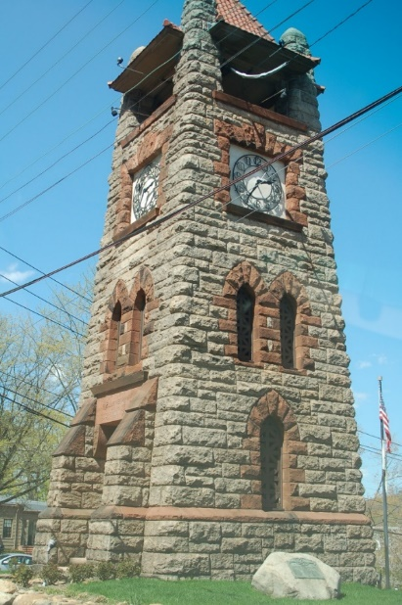

WALKING TOUR 2022
This year the Roslyn Landmark Society will be hosting a Walking Tour of Roslyn Village. The tour will begin at the Roslyn Landmark Society’s Headquarters, (36 Main Street) and head down Main Street, over to East Broadway then into the Village to visit the historic Roslyn Grist Mill and Ellen E. Ward Clock Tower. Two tours will be given at 10am and 1pm and is free of charge for current 2022 members and a suggested donation of $25 for non-members. Tours will be limited to 20 people per tour. The Roslyn Landmark Society is a 501(C) 3 organization. All contributions are tax deductible as allowed by law.

Ticket Sales
2022 Members – Free
Non – Members: A $25 suggested donation which will include a 2022 membership)
To Register please choose a scheduled Tour time.

Walking Tour – 10:00am
https://www.eventbrite.com/e/roslyn-landmark-society-walking-tour-10am-tour-tickets-333670897637
Walking Tour – 1:00pm
https://www.eventbrite.com/e/roslyn-landmark-society-walking-tour-1pm-tour-tickets-344247021107

Saturday, June 4, 2022

Roslyn Landmark Society

